Cypto Perspective

COIN PRICE WEB - FE
MEETING MINUTES

LOCATION: | Họp Online bằng Google Meet
Link record: | https://youtu.be/PA5vfp2vq5o
Date: | 01/11/2024
Attendees: | Bùi Thế Kỷ Cương (PO)
ABSENT: | No
Time: | 20:00 PM

Agenda Items
- Previous Meeting Tasks
- This Week’s Meeting Task
1. Báo cáo tiến độ của team FE Coin Price
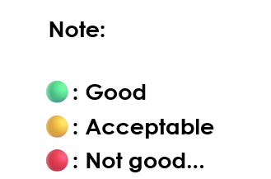
- Members’ Process Record:
members’ name | tasks |  | Deadline | Status
Bùi Thế Kỷ Cương |  | Thuyết trình. | N/A | 🟢
Tất cả thành viên nhóm |  | Nắm thông tin | N/A | 🟢
- Troubles & Problems

1. Problem #1

IV. Agreements On Next Week’s Meeting
tasks | Deadline

